

IRF24/2162

Gateway determination report – PP-2024-1406

Parramatta CBD Supplementary Matters

September 24

Published by NSW Department of Planning, Housing and Infrastructure

[dpie.nsw.gov.au](http://www.dpie.nsw.gov.au/)

Title: Gateway determination report – PP-2024-1406

Subtitle: Parramatta CBD Supplementary Matters

© State of New South Wales through Department of Planning, Housing and Infrastructure 2024. You may copy, distribute, display, download and otherwise freely deal with this publication for any purpose, provided that you attribute the Department of Planning, Housing and Infrastructure as the owner. However, you must obtain permission if you wish to charge others for access to the publication (other than at cost); include the publication in advertising or a product for sale; modify the publication; or republish the publication on a website. You may freely link to the publication on a departmental website.

Disclaimer: The information contained in this publication is based on knowledge and understanding at the time of writing (September 24) and may not be accurate, current or complete. The State of New South Wales (including the NSW Department of Planning, Housing and Infrastructure), the author and the publisher take no responsibility, and will accept no liability, for the accuracy, currency, reliability or correctness of any information included in the document (including material provided by third parties). Readers should make their own inquiries and rely on their own advice when making decisions related to material contained in this publication.

Acknowledgment of Country

The Department of Planning, Housing and Infrastructure (the Department) acknowledges the Traditional Owners and Custodians of the land on which we live and work and pays respect to Elders past, present and future.

Contents

1 Planning proposal 3

1.1 Overview 3

1.2 Objectives of planning proposal 3

1.3 Site description and surrounding area 3

1.4 Explanation of provisions 5

1.5 Mapping 6

1.6 Background 9

2 Need for the planning proposal 10

3 Strategic assessment 10

3.1 District Plan 10

3.2 Local 11

3.3 Local Planning Panel recommendation 12

3.4 Section 9.1 Ministerial Directions 12

3.5 State environmental planning policies (SEPPs) 15

4 Site-specific assessment 16

4.1 Environmental 16

4.2 Social and economic 17

4.3 Infrastructure 17

5 Consultation 18

5.1 Community 18

5.2 Agencies 18

6 Timeframe 18

7 Local plan-making authority 19

8 Assessment summary 19

9 Recommendation 19

Table 1 Reports and plans supporting the proposal

|  |
| --- |
| Relevant reports and plans |
| Planning Proposal dated June 2024 |
| Council Report and Minutes dated 11 June 2024 |
| Local Planning Panel Report and Minutes dated 21 May 2024 |
| Parramatta CBD Integrated Transport Plan dated July 2021 |
| Parramatta CBD planning proposal submission Council Minutes and Resolutions, dated 15 June 2021 |
| Achieving A-Grade Office in Parramatta CBD prepared by Urbis, dated 2019 |
| Parramatta High Performance Building Study prepared by Kinesis, dated December 2023 |
| Updated Parramatta Flood Risk Management Plan prepared by Molino Stewart, dated October 2021 |
|  |

# Planning proposal

## Overview

Table 2 Planning proposal details

|  |  |
| --- | --- |
| LGA | Parramatta |
| **PPA** | City of Parramatta |
| **NAME** | Parramatta CBD Supplementary Matters |
| **NUMBER** | F2021/03261 |
| **LEP TO BE AMENDED** | Parramatta Local Environmental Plan (LEP) 2023 |
| **ADDRESS** | Parramatta CBD and 10-12 Darcy Street, Parramatta |
| **DESCRIPTION** | See section 1.3 and Figure 1 |
| **RECEIVED** | 27/06/2024 |
| **FILE NO.** | IRF24/2162 |
| **POLITICAL DONATIONS** | There are no donations or gifts to disclose and a political donation disclosure is not required |
| **LOBBYIST CODE OF CONDUCT** | There have been no meetings or communications with registered lobbyists with respect to this proposal |

## Objectives of planning proposal

The planning proposal contains objectives and intended outcomes that adequately explain the intent of the planning proposal.

The objectives of the planning proposal are to amend *Parramatta Local Environmental Plan 2023* (PLEP 2023) to:

* Finalise a number of outstanding matters remaining from the Parramatta CBD Planning Proposal.
* Facilitate employment outcomes in the Parramatta CBD by securing and incentivising capacity for office development and enabling creative industries.
* Improve transport and access outcomes by updating the land reservation acquisition for some laneways and road widenings, and also allowing for additional on-site car parking in North Parramatta.
* Improve environmental outcomes in the Parramatta CBD by updating the Building Sustainability Index (BASIX) exceedance targets for residential towers and enabling water recycling facilities.

## Site description and surrounding area

The planning proposal affects the whole Parramatta CBD as well as specific areas within the CBD.

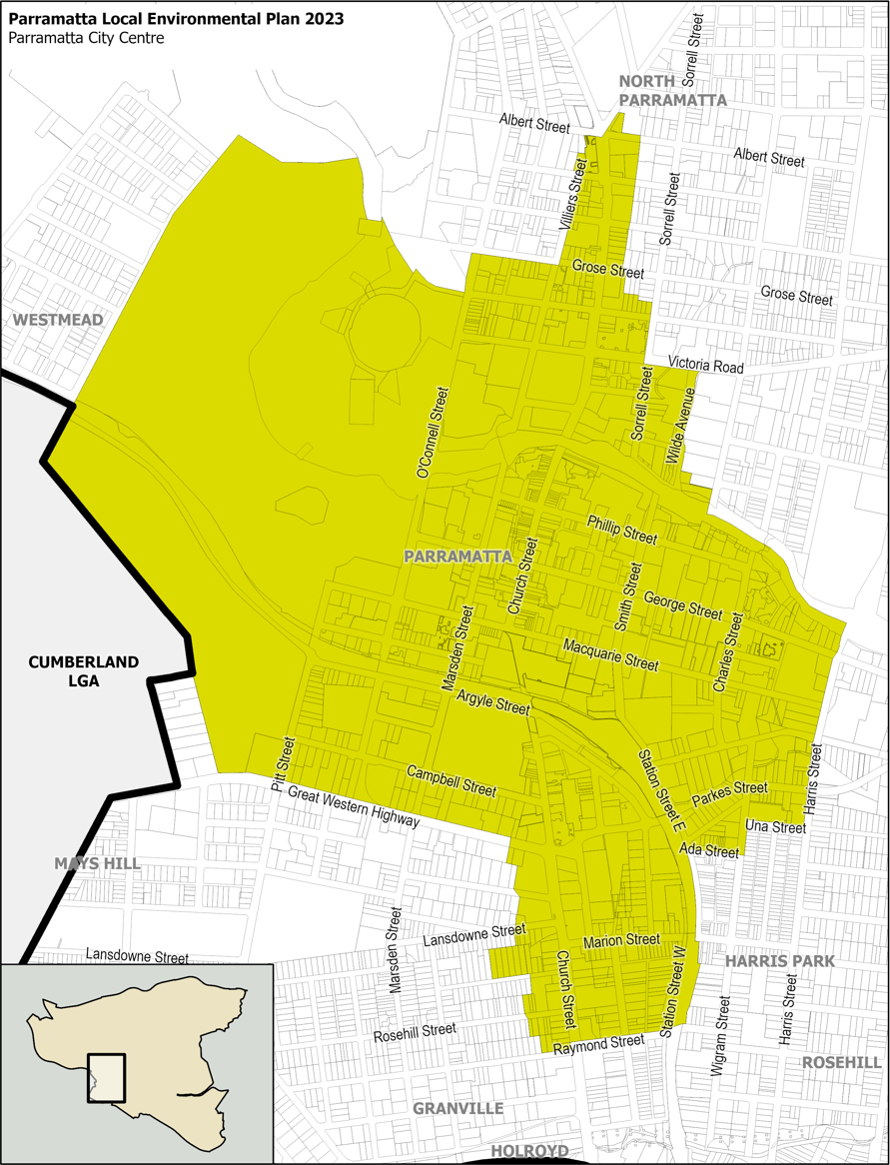

**10-12 Darcy St, Parramatta**

**North Parramatta**

Figure 1: Parramatta CBD and specific sites outlined in red and blue (Source: Planning proposal report, 2024

10-12 Darcy Street, Parramatta or Lot 83 and 84, DP 1271742 (outlined in red) is located north of the Parramatta Train Station and is also known as 4,6 & 8 Parramatta Square. The land proposed to be rezoned is approximately 9,727m2 in area and contains 4 existing recently developed commercial buildings.

The proposed car parking provisions will apply to North Parramatta (outlined in blue). Generally, this area is a mixture of older residential flat buildings, multi dwelling houses and dwelling houses.

## Explanation of provisions

The planning proposal seeks to amend the Parramatta LEP 2023 per the changes below:

1. **Rezone land at 10-12 Darcy Street, Parramatta** (also known as 4, 6 & 8 Parramatta Square) from MU1 Mixed Use to E2 Commercial Centre. The current commercial core will be expanded through this amendment.
2. **Apply clause 7.28 *Additional floor space ratio for office premises*** **to 10-12 Darcy Street, Parramatta** to allow the maximum permitted FSR to be exceed if the additional GFA is used for office premises.
3. **Amend various relevant Land Reservation Acquisition (LRA) maps** for laneways and road widening. Refer to section 1.5 of this report for further details.
4. **Amend table under clause 7.17(2)** to introduce appropriate parking rates for residential development located on the fringe of the CBD as per Parramatta CBD Integrated Transport Plan (ITP). The ITP recommended a higher car parking rate requirement for areas which are not within:

* 800m or 10 min walk from Parramatta Station
* 800m or 10 min walk from future Metro Station
* 400m or 5 min walk from Harris Park Station

The new parking rate will apply to North Parramatta and include a new mapping series (Land Use and Transport Integration Map). The current parking rate in place will be identified as Category A and the new parking rate will be identified as Category B. Clause 7.17(2) may be amended to reference the new mapping. The proposed changes to the clause are in red as below:

|  |  |
| --- | --- |
| Land use | Maximum number of car parking spaces |
| Residential flat buildings, dual occupancies and multi dwelling housing for land identified as Category A on the Land Use and Transport Integration Map | The sum of the following—  (a) 0.1 space for each studio dwelling,  (b) 0.3 space for each dwelling containing 1 bedroom,  (c) 0.7 space for each dwelling containing 2 bedrooms,  (d) 1 space for each dwelling with 3 or more bedrooms |
| Residential flat buildings, dual occupancies and multi dwelling housing for land identified as Category B on the Land Use and Transport Integration Map | The sum of the following - Resident spaces:  (a) 0.2 space for each studio dwelling,  (b) 0.4 space for each dwelling containing 1 bedroom,  (c) 0.8 space for each dwelling containing 2 bedrooms,  (d) 1.1 spaces for each dwelling with 3 or more bedrooms,  Visitor spaces (calculated cumulatively):  (e) 0.167 space for each dwelling up to 30 dwellings,  (f) 0.1 space for each dwelling more than 30 and up to 70 dwellings,  (g) 0.05 space for each dwelling more than 70 dwellings |

1. **Amend** the **land use table for E2 Commercial Centre zone** by including **“Creative Industries”** and **“Water recycling facilities”** as land uses permitted with consent.
2. **Amend the table under clause 7.25(3)(c)(ii)** to reflect the current Sustainable Buildings SEPP and Parramatta High Performance Building Study Review. The proposed amendments simplify the criteria table. The current and proposed provisions are as follows-

**Table 3 Current and proposed controls**

|  |  |
| --- | --- |
| Current LEP provision | Proposed provision |
| |  |  |  | | --- | --- | --- | | Height of building | Building with FSR of at least 6:1 but less than 14:1 | Building with FSR of at least 14:1 | | **BASIX points** | **BASIX points** | | 5–15 storeys | 25 | 15 | | 16–30 storeys | 20 | 10 | | 31–40 storeys | 10 | 10 | | 41 or more storeys | 10 | 10 | | |  |  | | --- | --- | | Height of building | Building with FSR ranging from 6:1 to 16:1 | | **BASIX points** | | 5–15 storeys | 25 | | 16–30 storeys | 20 | | 31–40 storeys | 10 | | 41 or more storeys | 10 | |

The planning proposal contains an explanation of provisions that adequately explains how the objectives of the proposal will be achieved.

## Mapping

The planning proposal includes mapping showing the proposed changes to the following maps, which are generally suitable for community consultation. No further amendments are proposed except for the proposed special provisions area map.

**Zoning Map**

The planning proposal seeks to amend the existing land zoning map to rezone the land identified in Figure 2 from MU1 Mixed Use to E2 commercial core. The proposed boundary reflects the extent of the existing building at 10-12 Darcy Street.

|  |  |
| --- | --- |
| Current | Proposed |
|  |  |

Figure 2 Proposed Zoning amendment for 10-12 Darcy Street, Parramatta outlined in red. (Source- Planning proposal report, 2024)

**Special provisions for additional floor space ratio for office premises - Area B**

The planning proposal seeks to “Amend the Special Provisions Area Map to include the Walker Corporation Landholdings sites as a part of Area B” under the planning proposal. However, the proposed mapping for special provisions area map on page 71 of the planning proposal report incorrectly also shows hatching for land to the south of the Parramatta station. A Gateway conditions is recommended to address this mapping error.

|  |  |
| --- | --- |
| Current | Proposed |
|  |  |

Figure 3 Proposed special provisions applied to 10-12 Darcy Street, Parramatta outlined in red. (Source- Planning proposal report, 2024)

**Land Reservation Acquisition Maps**

The planning proposal includes amendments to the LRA Mapping applicable to the Parramatta CBD. The affected properties are outlined in red, the LRA locations are highlighted in yellow and the hatched areas are proposed to be amended at the following locations:

1. 328 Church Street, Parramatta

|  |  |
| --- | --- |
| Current | Proposed |
|  |  |

Figure 4: LRA amendment- partial deletion of the of reserve (Source- Planning proposal report, 2024)

1. Marsden Lane, being part of 215 Church Street, Parramatta

|  |  |
| --- | --- |
| Current | Proposed |
|  |  |

Figure 5: LRA amendment- deletion of the of reserve (Source- Planning proposal report, 2024)

1. Fire Horse Lane, being part of 3 Fitzwilliam Street, and 25 Wentworth Street, Parramatta

|  |  |
| --- | --- |
| Current | Proposed |
|  |  |
| Figure 6: LRA amendment- partial deletion of the of reserve (Source- Planning proposal report, 2024) | |

1. Insert new LRA at:

* Woodhouse Lane, being part of 21 Wentworth Street, Parramatta
* Charles Street/Hassall Street Intersection, being part of 2 Charles Street, Parramatta
* Parkes Street widening, being part of 24 Parkes Street, Harris Park

|  |  |  |
| --- | --- | --- |
| Woodhouse Lane | Charles Street/Hassall Street | Parkes Street widening |
|  |  |  |

Figure 7: LRA amendment- insertion of new reserves (Source- Planning proposal report, 2024)

**Land Use and Transport Integration Map (proposed)**

Figure 8: Proposed Land Use and Transport Integration Map showing Category A and Category B residential car parking rate area (Source- Planning proposal report, 2024)

## Background

**Parramatta CBD Planning Proposal (Amendment 56 to PLEP 2011)** introduced the existing planning framework for the Parramatta CBD, effective from 14 October 2022.

The proposed amendments of the planning proposal relate to matters raised during exhibition of the Parramatta CBD planning proposal. In its post exhibition assessment of the submissions, Council deemed some of the raised matters as not minor in nature and requiring further investigation.

These unresolved submissions are referred to as the ‘Orange matters’ throughout the documents submitted for this planning proposal. The complete list of council’s assessment and recommendation for the ‘Orange matters’ is attached to the Council and the Local Planning Panel (LPP) reports.

The submissions relevant to the planning proposal include:

* Parramatta River Catchment Group, an alliance comprised of local and state government agencies and community groups focusing on river catchment environment rehabilitation sought to include two new land uses- “Water supply” and “Water recycling facility” in the E2 Commercial Centre zone.
* Walker Corporation made a submission to amend the zoning for 10-12 Darcy Street, Parramatta from Mixed use (referred to as B4 Mixed Use prior to the Employment zones reform) to Commercial Centre (referred to as B3 Commercial Core zone Use prior to the Employment zones reform).
* Walker Corporation also sought to include “Creative industry” as an additional permitted use as the proposed commercial zone would impact future development of the existing premise for ABC studios.

**Parramatta Integrated Transport Plan** (ITP), was prepared as part of Parramatta CBD planning proposal Gateway determination requirement and was finalised in August 2021. The ITP made several recommendations which will contribute to establishing a framework for planning and developing Parramatta CBD transport system. As a result of the findings of the ITP, Council resolved to:

* apply different parking rate to land in the CBD fringe based on the access to current train stations and future Metro station
* update Land Reservation Acquisition mapping as per Council’s current servicing priorities

***State Environmental Planning Policy (Sustainable Buildings)*** ***2022***

The Sustainable Buildings SEPP was made in August 2022 and was effective from 1 October 2023. The SEPP included revised compliance targets and updates to the BASIX calculator. Following implementation, Parramatta Council engaged Kinesis to assess the impact of the amendments to the BASIX system and recommend updated targets for the LEP controls to continue to incentivise high performance buildings in Parramatta CBD. The **Parramatta High Performance Building Study** recommended new target exceedance points for BASIX water and energy. Council resolved to only adopt the energy targets.

# Need for the planning proposal

The Parramatta CBD supplementary matters planning proposal (this proposal) is a result of:

* Council endorsed position on submissions received during the exhibition of the Parramatta CBD Planning Proposal
* Additional LPP recommendation
* Requirement to update various controls in the LEP in accordance with local and state government’s latest policy positions

The proposed amendments through this planning proposal are the best means to directly achieve the intended results without requiring implementation of specific local provisions. Additionally, the proposed amendment to the LEP will continue to provide suitable support and incentives for developments within Parramatta CBD and reducing restrictions where appropriate. The planning proposal will provide certainty for Council, the local community, developers and landowners to allow for the orderly and economic development of the land.

# Strategic assessment

## District Plan

Parramatta CBD is located within the Central City District. The Greater Sydney Commission released the ‘Central City District Plan’ (District Plan) on 18 March 2018. The District Plan contains planning priorities and actions to guide the growth of the district while improving its social, economic and environmental assets.

The planning proposal is consistent with the priorities for infrastructure and collaboration, liveability, productivity, and sustainability in the plan as outlined below.

The Department is satisfied that the planning proposal gives effect to the District Plan in accordance with section 3.8 of the *Environmental Planning and Assessment Act 1979* (EP&A Act). The planning proposal is consistent with the planning priorities of the District Plan, as per below:

* ***C1 Planning for a city supported by Infrastructure:*** The proposed LRA amendments will give effect to this priority by implementing updates that reflect Council’s current infrastructure investment priorities and servicing plan/s.
* ***C5 Providing housing supply choice and affordability with access to jobs, services and public transport:*** The proposed amendments to clause 7.25 relating to BASIX points updates will assist in providing incentives for residential development throughout the CBD. The proposed new category of parking rate controls will ensure that residential development located on the fringe of the CBD has reduced reliance on street parking by having more on-site parking, as these fringe areas have reduced access to current train and future Metro stations.
* ***C9 Delivering integrated land use and transport planning and a 30-minute city***: The planning proposal seeks to implement outcomes of the Parramatta Integrated Transport Plan. The proposed amendments will contribute to efficient traffic movements in Parramatta CBD road network.
* ***C11 Maximising Opportunities to attract advanced manufacturing and innovation in industrial and urban services land:*** The proposed inclusion of creative industries in the current E2 zone will attract innovative business establishments across all of Parramatta CBD. Previously this would have been restricted to the mixed-use zoned land only.

## Local

The planning proposal states that it is consistent with the following local plans and endorsed strategies. It is also consistent with the strategic direction and objectives, as stated in the table below:

|  |  |
| --- | --- |
| Local Strategies | Justification |
| Local Strategic Planning Statement | The planning proposal will give effect to the City of Parramatta’s Local Strategic Planning Statement by-   * Planning priority 1 and 11- Expanding the current commercial core in an orderly manner and enhancing the desirability of new creative business operations through expanding the permissible land uses in the E2 Commercial Centre Zone. * Planning priority 10 - Implementing changes to enable suitable transport planning and reduce street parking reliance. * Planning priority 15 - Incentivising development of buildings with high sustainability targets and expanding establishment of water recycling facilities in the CBD. |
| Parramatta CBD Planning Strategy | The planning proposal is considered to be consist with this strategy by giving effect to development and transport planning framework for Parramatta CBD. The proposed amendment will continue to support the planned growth for the Parramatta CBD, incentivise higher quality development while addressing the specific local planning needs. |
| Parramatta Integrated Transport Plan (ITP) | This planning proposal is consistent with the ITP. It should be noted that the ITP recommends the new parking rate category to be applied to 3 areas of the CBD, however, some of the areas were not proposed to be amended as part of this proposal. As per figure 9 below, the category B parcel west of Parramatta Park is Parramatta High School, which is not likely to be re-developed for other uses. The category B parcels located south of the CBD are zoned E2 Commercial Centre, which does not permit residential development. Any future development of these sites through application of the SEPP will have to comply with the relevant parking rate under the instrument. Alternatively, re-development of these sites through rezoning can also include amendment to the parking rates applicable to these parcels.    Figure 9: ITP recommendation for car parking rate (Source- Planning proposal report, 2024)  Although the ITP was prepared in conjunction with Transport for NSW (TfNSW), formal endorsement has not been attained. In this regard, a Gateway condition is recommended requiring consultation with TfNSW. |

## Local Planning Panel recommendation

The planning proposal was reported to the Parramatta Local Planning Panel (LPP) on 21 May 2024 in accordance with requirements of section 2.19 of the EP&A Act. The LPP supported that the planning proposal with the recommendation to update the planning proposal to include “Creative Industries” as a permissible land use with consent for the E2 Commercial Centre zone under the LEP.

## Section 9.1 Ministerial Directions

The planning proposal’s consistency with relevant section 9.1 Directions is discussed below:

Table 7 9.1 Ministerial Direction assessment

|  |  |  |
| --- | --- | --- |
| Directions | Consistent/ Not Applicable | Reasons for Consistency or Inconsistency |
| 3.2 Heritage Conservation | Yes | The objective of Direction 3.2 is to conserve items, areas, objectives and places of environmental heritage significance and indigenous heritage significance.  The proposal includes rezoning of 10-12 Darcy Street, Parramatta which is surrounded by several heritage items. It also includes amendments to the land reservation acquisition mapping, including properties that are identified to have heritage significance.  The proposal does not seek to amend the heritage listings in the LEP or reduce the ongoing application of existing LEP and DCP provisions for heritage conservation.  The proposal is considered consistent with this Direction.  See section 4.1 for further discussion. |
| 4.1 Flooding | Justified inconsistency | This Direction seeks to ensure development of flood prone land is consistent with the Flood Risk Management Manual and ensure LEP provisions are commensurate with the flood behaviour and consider the potential impacts on and off the land.  The site at 10-12 Darcy St and surrounding area is identified as being flood prone in PMF flood event, and in a minor portion, the 1 in 20 year event. This direction applies as the proposal seeks to apply clause 7.28 of Parramatta LEP 2023, altering development standards that apply to a site identified as flood prone through incentives for office floor space.  It is noted that the land has recently been developed for high density commercial, and any substantial redevelopment of the site is unlikely.  The planning proposal notes that the site is located in the low-risk possible maximum flood (PMF) area. Council considers that the planning proposal is in accordance with the Parramatta Floodplain Risk Management Plan (Molino Stewart 2021) which is Council’s adopted floodplain risk management study. In this regard, inconsistency with this direction is considered to be minor and justified as per the terms of this direction. |
| 4.5 Acid Sulfate Soils | Justified inconsistency | The objective of this direction is to avoid significant adverse environmental impacts from the use of land that has a probability of containing acid sulfate soils.  The site is mapped as potentially containing Class 5 acid sulfate soils.  The proposed rezoning of the land at 10-12 Darcy Street may enable land use intensification. As such the proposal is inconsistent with this direction.  This inconsistency is of minor significance as Class 5 acid sulfate soils are a low risk class and the Parramatta LEP 2023 contains suitable provisions to ensure that this matter can be appropriately considered and addressed as part of any future development application involving any excavation.  The proposal is therefore justifiably inconsistent with this direction. |
| 5.1 Integrating Land Use and Transport | Yes | The proposal is deemed consistent with this direction as the proposed CBD fringe area parking rates gives effect to Council’s recently prepared Integrated Transport plan by seeking amendments which will result in efficient movement of local traffic. Additionally, the proposed changes to the car parking rate recognises the limited access to public transport for the CBD fringe area. These amendments will ensure that any future development incorporate appropriate amenities for private transport into the design of the development. |
| 5.2 Reserving Land for Public Purposes | Yes | This Direction related to the administrative processes behind the creation, removal or alteration of reservations of land for public purposes.  Under this Direction, a planning proposal must not create, alter or reduce existing rezonings or reservations of land for public purposes with the approval of the relevant authority and the Secretary (or delegate) of the Department.  The planning proposal alters existing reservation areas identified for acquisition through the creation of new area, as well as the removal of reservation status of lands that are no longer required. The proposed changes derived from the Council’s Integrated Transport Plan.  The proposal is consistent with this Direction as the amendments:   * have been endorsed by Council (15 June 2021) * will be approved by a delegate of the Planning Secretary, subject to a favourable Gateway Determination and any subsequent finalisation of the LEP. |
| 6.1 Residential Zones | Justified inconsistency | Direction 6.1 aims to encourage a variety of housing types, make efficient use of infrastructure and services and minimise the impact of residential development on the environment.  The proposed rezoning of land will result in residential development no longer being permitted for 10-12 Darcy Street, Parramatta under the PLEP 2023. The inconsistency is minor because:   * it formalises the existing use on the site * build-to-rent will continue to be permitted in the E2 Commercial Core, permitting a form of residential development on the site * the subject site was recently developed for high-density commercial use so residential development on the site is unlikely |
| 7.1 Employment Zones | Yes | The proposal will rezone land to an employment zone from mixed use zone which is also considered to be an employment zone for the purpose of this direction. In this regard, the proposal is consistent with this direction. |

## State environmental planning policies (SEPPs)

The planning proposal is consistent with all relevant SEPPs as discussed in the table below-

Table 8 Assessment of planning proposal against relevant SEPPs

|  |  |  |  |
| --- | --- | --- | --- |
| SEPPs | Requirement | Consistent/ Not Applicable | Reasons for Consistency or Inconsistency |
| [State Environmental Planning Policy (Housing) 2021](https://legislation.nsw.gov.au/view/html/inforce/current/epi-2021-0714) | Aims to provide diverse housing types, including affordable housing in appropriate locations | Yes | The proposed rezoned land can be redeveloped for built-to-rent using the provisions of this SEPP. |
| [State Environmental Planning Policy (Sustainable Buildings) 2022](https://legislation.nsw.gov.au/view/html/inforce/current/epi-2022-0521) | Aims to encourage the design and delivery of sustainable buildings and provide a consistent assessment framework for sustainable development. | Yes | The amendment to BASIX exceedance table gives effect to this SEPP to encourage development of high-quality sustainable buildings. |
| [State Environmental Planning Policy (Transport and Infrastructure) 2021](https://legislation.nsw.gov.au/view/html/inforce/current/epi-2021-0732) | The SEPP aims to facilitate the effective delivery of infrastructure​ | Yes | The proposal will enable works for the road reserves which will utilise the provisions of this SEPP. |

# Site-specific assessment

## Environmental

The following table provides an assessment of the potential environmental impacts associated with the proposal.

Table 9 Environmental impact assessment

|  |  |
| --- | --- |
| Environmental Impact | Assessment |
| Heritage impact | The planning proposal will amend zoning for 10-12 Darcy Street, Parramatta which adjoins several heritage items. The rezoning at this stage is more administrative in nature and these sites are not likely to be re-developed soon as the site was recently developed for high density commercial. Any future development can be adequately assessed through the current LEP controls for Heritage conservation (Clause 5.10), as well as the heritage controls specific to Parramatta CBD in Parramatta DCP 2023.    Figure 9: Heritage items affected by this proposal (Source- spatial viewer, 2024)  The LRA amendment to 215 Church Street Parramatta will only remove current mapping notation and will not have any impact to the subject heritage item.  The LRA amendment to 21 Wentworth Street, Parramatta will enable a 3m x 3m corner splay at the rear of the site. It is deemed that the rear boundaries of the heritage item (attached houses) have been altered during the construction of adjoining Wentworth Street Multi-storey Public Carpark. As such, the proposed new construction impact is considered minor in nature. |
| Sustainable development practices | The proposed amendments to clause 7.25 relating to BASIX exceedance points will enhance application of incentives through a simplified category table for developing buildings with the highest level of energy efficient design practices. Additionally, the new permitted land use for water recycling facilities will ensure that the application of requirement for Dual Water system in new development remains consistent across all zones within the CBD. |
| Flooding | As discussed under section 3.4 Direction 4.1 Flooding. |
| Acid Sulphate Soil | As discussed under section 3.4 Direction 4.5 Acid Sulfate Soils |

## Social and economic

The following table provides an assessment of the potential social and economic impacts associated with the proposal.

Table 10 Social and economic impact assessment

|  |  |
| --- | --- |
| Social and Economic Impact | Assessment |
| Employment | The inclusion of creative industries in the E2 zone will enhance the permitted uses across the CBD and attract more creative industries such as studios or production facilities etc to Parramatta CBD.  The extension of special provision to exceed FSR for office premises to the proposed rezoned land will enable further development of the existing buildings for additional office spaces, should that become viable. |
| Amenity - Car parking | The CBD fringe areas have limited access to frequent mass transport systems (Trains and Metro). The proposed new parking rate will recognise that residents of these areas have reduced choice of accessible public transport and as such they may rely more on private vehicles to make their day-to-day trips. The new car parking rate will provide suitable amenity for the residents by requiring more on-site parking for new developments. |

## Infrastructure

The following table provides an assessment of the adequacy of infrastructure to service the site and the development resulting from the planning proposal and what infrastructure is proposed in support of the proposal.

Table 11 Infrastructure assessment

|  |  |
| --- | --- |
| Infrastructure | Assessment |
| Roads | Council’s Integrated Transport Plan recommends several changes to Council’s existing Land Reservation Acquisition Map designed to provide:   * Strategic opportunities to improve capacity and capability of the existing road network, having regard to the significant growth within the Parramatta CBD as well as inherent existing constraints, such as heritage and existing significant development. * Opportunities to improve public transport capability through localised intersection improvements and augmentation of existing bus lanes. * Opportunities for a regional cycleway network within the Parramatta CBD. * Opportunities to improve pedestrian safety and capacity.   The proposed amendments will enable Council to adequately service the CBD by identifying areas that had not been previously included for acquisition, as well as, deleting reserves no longer required allowing re-allocation of funding for other community works within City of Parramatta. |
| Grey Water recycling | Clause 7.24 of the PLEP 2023 requires new development to include dual water reticulation system containing pipes for potable water and recycled water for all inside and outside water uses. A water recycling facility treats sewage effluent, stormwater or wastewater for use as an alternative supply to mains water, groundwater or river water. Currently, this land use is only permitted in MU1 zoned land, not E2 zoned land, limiting locations where a water recycling facility can be developed. Inclusion of the new land use in the Land use table will complement the current provisions and optimise efficient water management for the Parramatta CBD. |

# Consultation

## Community

The planning proposal is categorised as standard under the LEP Making Guidelines (September 2022). Accordingly, a community consultation period of 20 working days is recommended and this forms part of the conditions to the Gateway determination.

## Agencies

The proposal does not specifically raise which agencies will be consulted. It is recommended the following agencies be consulted on the planning proposal and given 30 working days to comment:

* Transport for New South Wales for the new car parking rates and amendments to the land acquisition reservation maps.

# Timeframe

The LEP Plan Making Guidelines (August 2023) establishes maximum benchmark timeframes for planning proposal by category. This planning proposal is categorised as standard.

The Department recommends an LEP completion date of 30 July 2025 in line with its commitment to reducing processing times and with regard to the benchmark timeframes. A condition to the above effect is recommended in the Gateway determination.

It is recommended that if the gateway is supported, it is accompanied by guidance for Council in relation to meeting key milestone dates to ensure the LEP is completed within the benchmark timeframes.

# Local plan-making authority

Council has advised that it would like to exercise its functions as a local plan-making authority.

As the planning proposal is considered minor in nature the Department recommends that Council be authorised to be the local plan-making authority for this proposal.

# Assessment summary

The planning proposal is supported to proceed with conditions for the following reasons:

* The proposal will give effect to the district and local plans applicable to Parramatta CBD.
* The proposed rezoning will continue to strengthen the commercial core of the CBD.
* The proposed amendments to the PLEP 2023 will ensure consistency in provisions for commercial development in the Parramatta CBD.
* The proposed LRA amendments will reflect Council’s current infrastructure servicing plan.

As discussed in the previous sections, the proposal should be updated to amend the proposed Special Provision Area map (page 71 of the planning proposal and any other relevant document) to remove the Area B hatching on the area south of Parramatta station.

# Recommendation

It is recommended the delegate of the Secretary:

* Agree that any inconsistencies with section 9.1 Directions 4.1 Flooding, 4.5 Acid Sulfate Soils and ​6.1 Residential Zones ​are minor

It is recommended the delegate of the Minister determine that the planning proposal should proceed subject to conditions.

The following conditions are recommended to be included on the Gateway determination:

1. The planning proposal and relevant accompanying documents are to be updated to amend the proposed Special Provision Area map to remove the Area B hatching on the area south of Parramatta station.
2. Consultation is required with the following public authorities:

* Transport for New South Wales

1. The planning proposal should be made available for community consultation for a minimum of 20 working days.
2. Given the nature of the planning proposal, it is recommended that the Gateway authorise Council to be the local plan-making authority.
3. The timeframe for the LEP to be completed is on or before 30 July 2025.

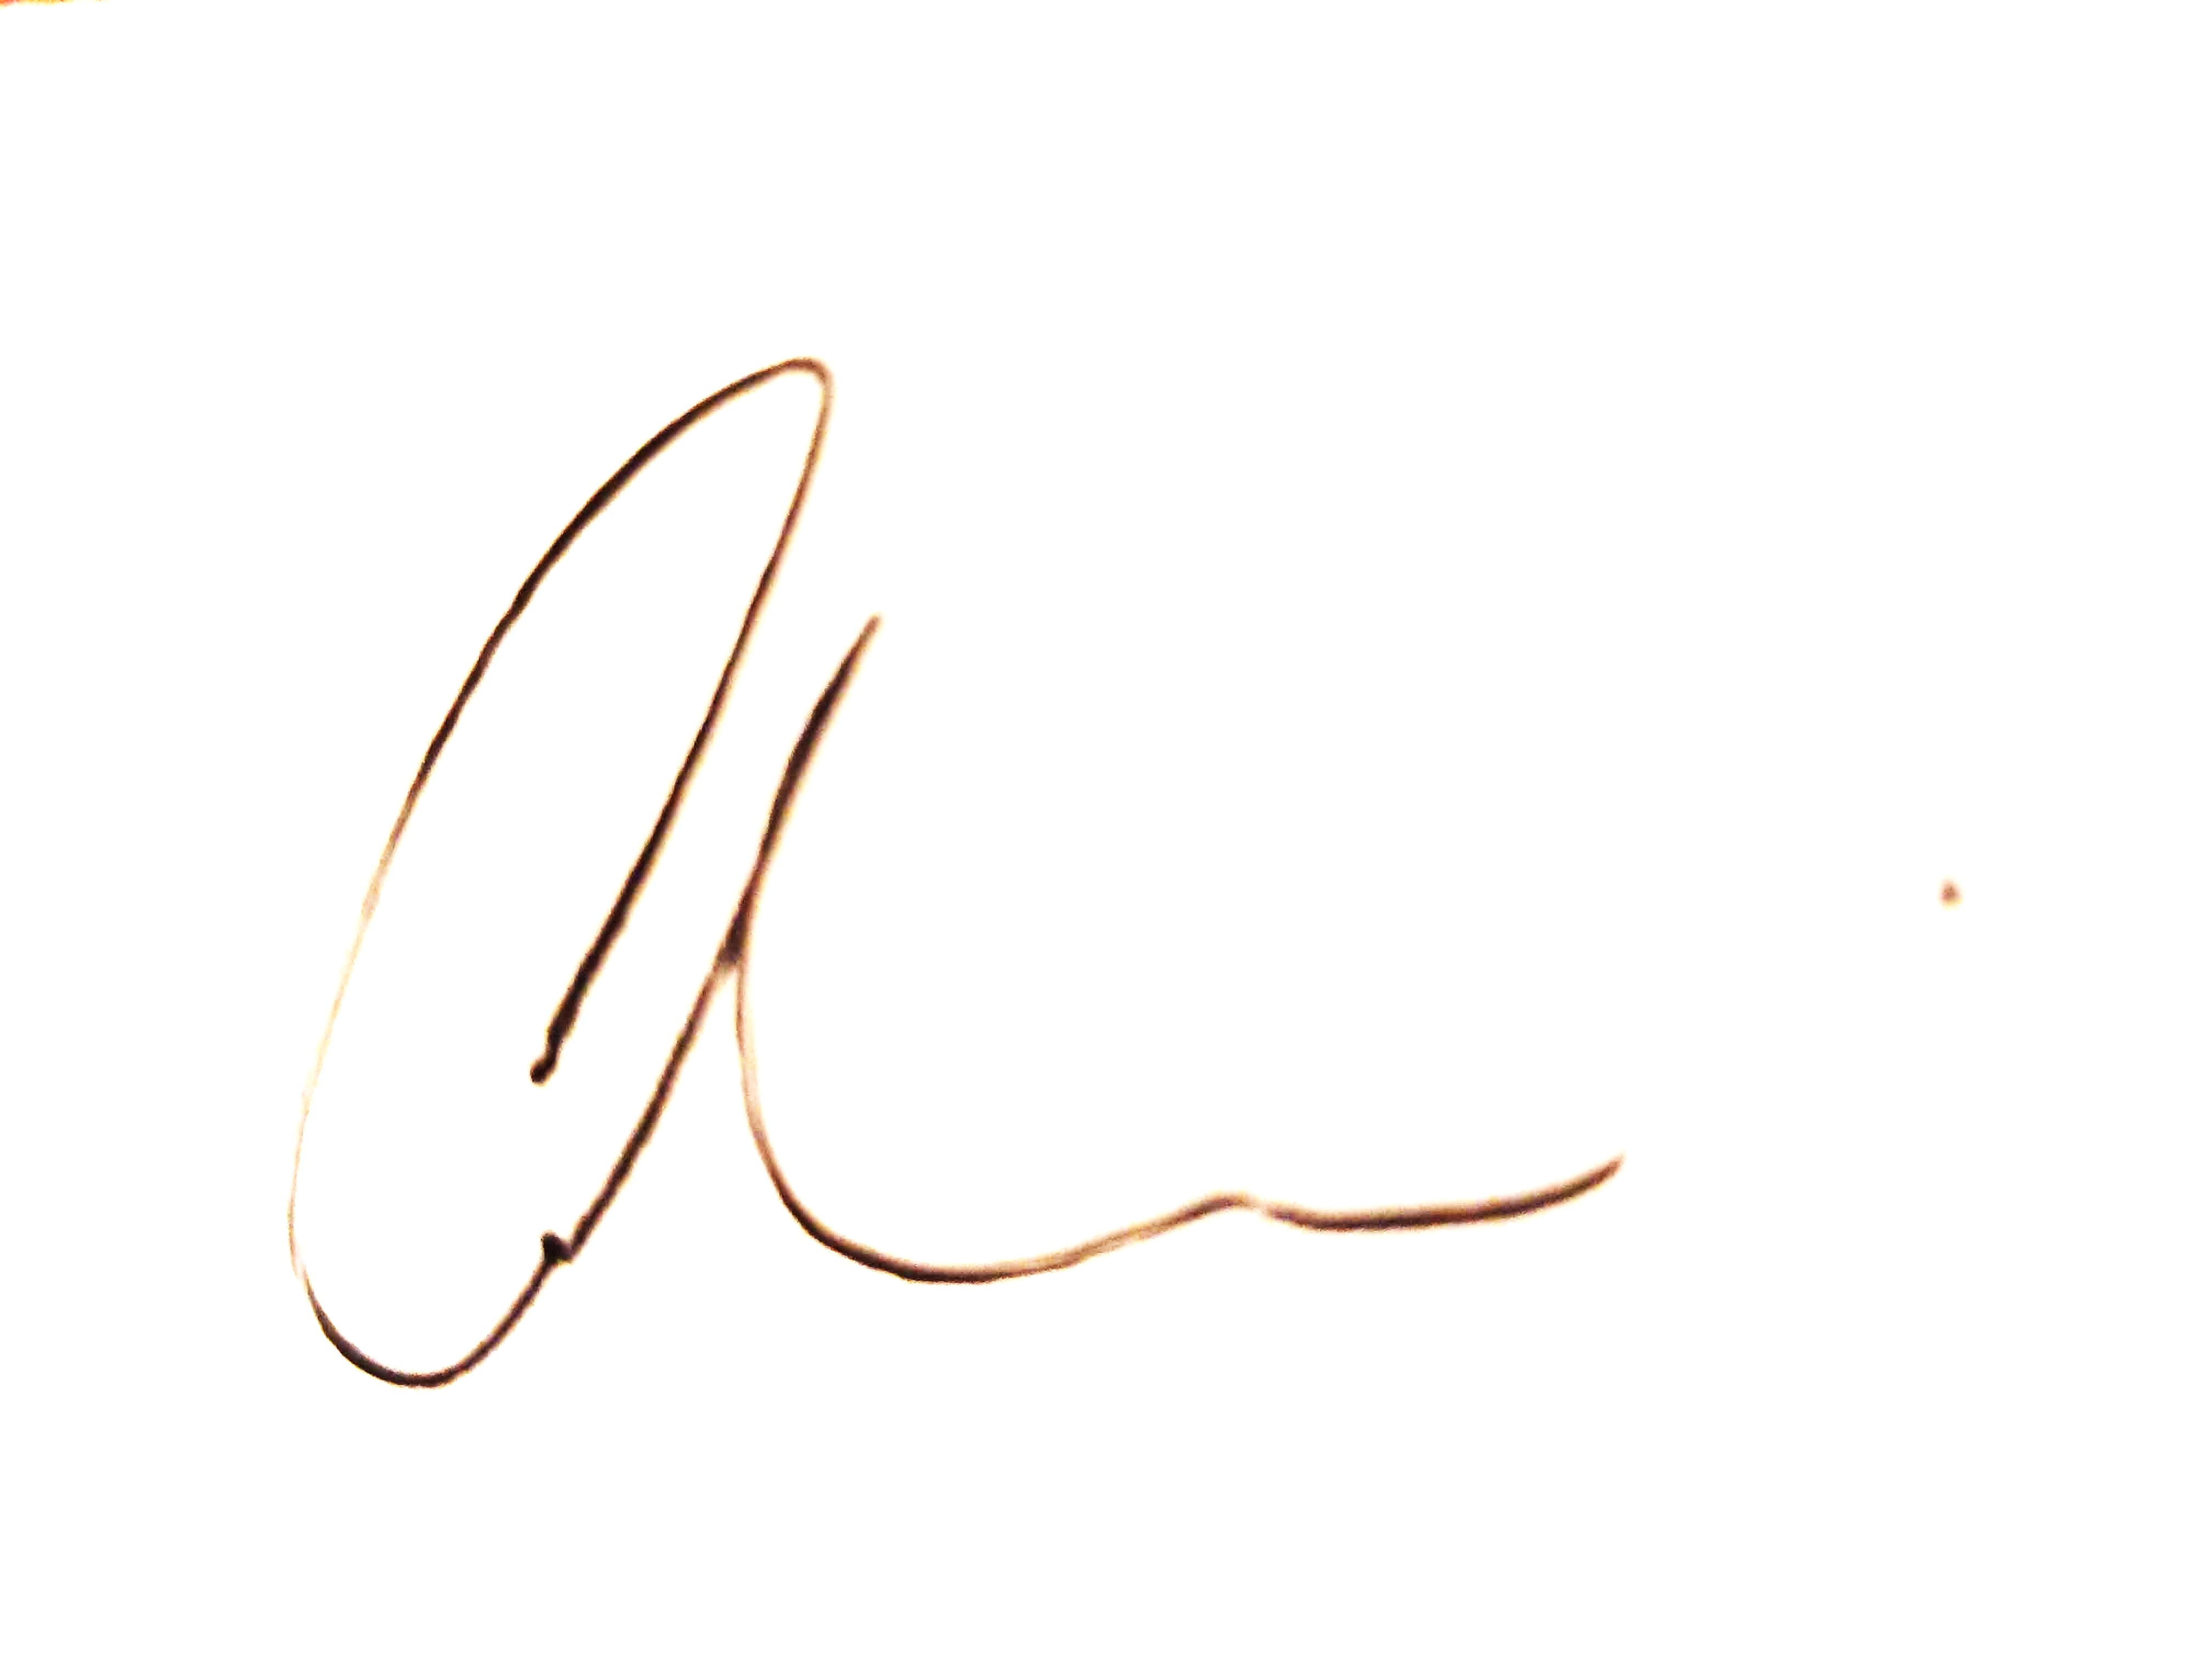 19 September 2024

Carina Lucchinelli

Manager, Metro Central, West and South

*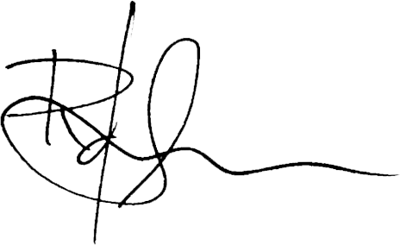 23 September 2024*

Rukshan de Silva

Director, Local Planning and Council Support

Assessment officer

Oyshee Iqbal

Planning Officer, Local Planning (Metro Central, West and South)

5852 6824